Shabbos Stories for
Parshas Chaya sarah 5776
Volume 7, Issue 10 25 Mar Cheshvon 5776/ November 7, 2015
Printed L’illuy nishmas Nechama bas R’ Noach, a”h

For a free subscription, please forward your request to keren18@juno.com

A Suggestion from the Gemara for Those in Need of Yeshuahs

Rabbi Yosef Weiss relates the following story (Visions of Virtue). Shimi and Shalom Storch were summoned to Mount Sinai Medical Center in Miami Beach.
The doctor spoke to Shalom, “I’m afraid that your mother Ruth suffered a heart attack during surgery. We managed to save her life, but she has lapsed into a coma.”
After a quiet moment, Shalom asked the doctor, “What’s the prognosis?” The doctor said, “It’s not very good, but there’s always hope.” The family stayed at their mother’s side for three months, and ignored the increasingly negative predictions of the doctors.
Somehow, Ruth clung to life, and they constantly beseeched Hashem for her recovery. One day, two people approached Shalom with a request while he was in the waiting room, presumably because he was an observant Jew.
One of them said, “Rabbi, there is a patient in the ICU who is critically ill and asked to see a Rabbi. Would you come speak with her?”
Shalom replied, “Certainly,” and he was brought to the gravely ill patient’s bedside.
“Rabbi,” the woman whispered, “I endured the horrors of the Holocaust. Although I am not observant, I never lost my faith. Please Daven for me.”
Shalom thought for a moment before he responded.
“Let me share a well-known story with you. A woman approached a Rabbi in Israel and asked him to pray for her, as she had been married for many years and only had one child. She begged, ‘Please Daven for me that I have another child.’ The Rabbi said to her, ‘There are so many other men who are of greater stature than me. Why don’t you approach them and ask them to Daven for you?’ The woman answered, ‘Rabbi, I have an instinctive feeling that the conduit for my blessing will come through you.’
The Rabbi, still hesitant, said to her, ‘I truly understand your feelings, as my daughter has been married for many years and is still childless. I have an idea. The Gemara says that if someone has a specific need, and he prays for someone else who also has that same need, then his prayers are answered first. I suggest that you pray for my daughter, while I pray for you.’
The woman agreed. Many years passed, and the Rabbi stuck to his end of the arrangement, although he never heard from that woman, and eventually, his daughter adopted a child.
Very soon after that, the thrilling news came that this daughter was expecting a child of her own! On the day that he celebrated the birth of his grandchild, the Rabbi received a phone call from the woman that he was Davening for, and she excitingly invited him to the Bris of her son!
After some quick questioning, the Rabbi discovered that this boy and his own grandchild were born within the same hour!” Shalom said to the woman, “I suggest that we adopt the same concept. I will Daven for you. I will go to my mother’s bedside where the Shechinah, Hashem’s Divine Presence, is resting, and I will mention your name, and you can Daven for my mother.”
The patient agreed and the two exchanged names to Daven for. The woman repeated Ruth’s name several times, and Shalom returned to his mother’s side, where he davened for both his mother and the other woman. Remarkably [or perhaps not remarkably], both women soon recovered and walked out of the hospital on their own!

Reprinted from the Parshas Lech Lecha 5776 email of Torah U’Tefilah: A Collection of Inspiring Insights Compliled by Rabbi Yehuda Winzelberg.
Rabbi Rescues Torah
Inside His Burning Shul
By Tess Cutler

A historic synagogue in New Brunswick, New Jersey, was reduced to a charred edifice on Friday after a devastating fire ravaged the nearly century-old building. But not everything was lost. During the blaze, Rabbi Abraham Mykoff, the rabbi at Congregation Poile Zedek, stormed into the burning shul to rescue a Sefer Torah in a miraculous display of James Bondian devotion. After retrieving the first scroll, Mykoff reportedly said that the ceiling immediately collapsed behind him.

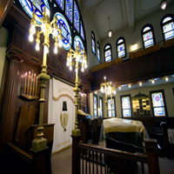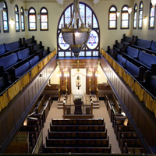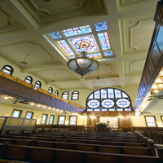
Photos from the shul website showing the inside of the shul before
the fire that destroyed Congregation Poile Zedek on October 23rd

Although the shul has been vandalized in the past, the exact cause of the fire remains to be identified.
The congregation was founded in 1901 by Russian and Polish immigrants. Twenty two years later, they built the synagogue, which was inducted into the National Register of Historic Places in 1995. Today, Congregation Poile Zedek is comprised of about 100 families.
Ari Goldring, who celebrated his bar mitzvah at the shul ten years prior is still mentally processing the damage done to the sanctuary. “It was such a beautiful building and it’s now all gone,” he told ABC 7, a local news channel. “I’m kind of numb.”
To rebuild, Congregation Poile Zedek, which, roughly translated, means “doers of righteousness,” has started a fundraising campaign.

Reprinted from the October 27, 2015 email of Tablet Magazine
New Brunswick Congregation Begins Picking up the Pieces
By Sue Epstein

NEW BRUNSWICK — Three days after a devastating fire destroyed historic Congregation Poile Zedek, the city's last surviving Orthodox Jewish congregation, its members are struggling to determine their future.
Armed with brooms, members began cleaning up broken glass outside and went inside to see what they could salvage from the building, dedicated in 1923.
But there isn't much other than the four walls.

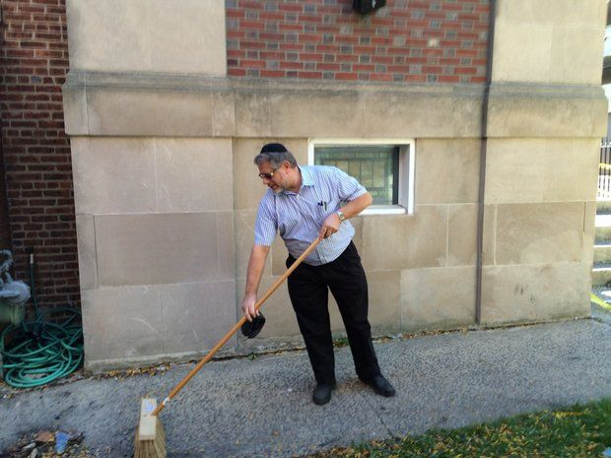
Kevin Zeff, member of Congregation Poile Zedek, starts cleanup Monday [October 26th] at historic synagogue in New Brunswick that was destroyed Friday by fire. (Photo by Sue Epstein | N.J. Advance Media)

Robert Dorfman, executive director of the synagogue, said Monday the congregation is working on arranging a place to hold services, but hasn't finalized anything yet.
Dorfman said "every congregation" in the areas has offered use of their sanctuary, but the logistics have to be worked out.
The fire was reported at 4:19 p.m. Friday and under control by 8 p.m., according to authorities, who said it started on the first floor. The cause appears to be accidental, officials said, but the specific cause is under investigation.
Poile Zedek's congregation is older and Orthodox congregation members walk to services on the Sabbath.

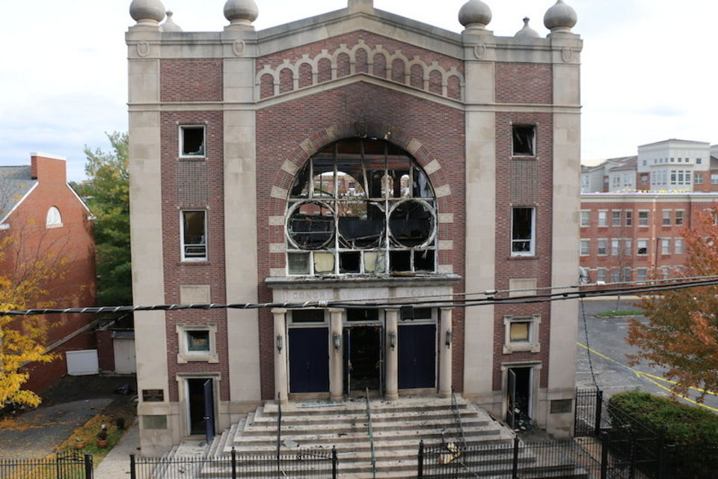
The remaining architectural shell of Congregation Poile Zedek that was a registered as a national historic site, following the destructive fire of Friday, October 23, 2015.

Dorfman said there are about 150 affiliated families in the congregation, which dates back about 150 years.
"The community has been absolutely wonderful," Dorfman said. "They have been volunteering to do all kinds of things, but the truth is, I don't know what we need yet. We're just in the early stages."
He said they want to rebuild the National Historic landmark, but "we're destitute."
"Nobody's a kid here," Dorfman said.
His assistant, Kevin Leff, began the cleanup Sunday and was on hand Monday, trying to sweep up the broken glass and other fragments left behind outside from the fire.
"He's one of the younger ones and he's in his 50's," Dorfman said.

There were between 10 and 12 sacred scrolls, known as Torahs, in the synagogue's sanctuaries. Rabbi Abraham Myckoff ran into the burning building Friday afternoon and managed to save one, but the others, including several about 100 years old, were destroyed. The silver adornments on them and the silver pointers used during services also melted during the fire.
"I told my wife now I understand when people say they are heartsick," Dorfman said. "It is more than a death."

He said he has received calls from around the country and other countries from people who heard about the fire, giving their support.
Rabbi Akiva Weiss, the former rabbi for the Rutgers Hillel in New Brunswick, wrote on his Facebook page that he was "devastated" by news of the fire and strove to create a stronger connection between the students at Hillel and the older congregants at Poile Zedek.
"I am so grateful beyond words for those four wonderful years I was able to give and receive from that special place called Poile Zedek," he said. "Hopefully others have had the same chance and experience and I look forward to seeing what I can do to help them now as well."

Reprinted from the October 26, 2015 website of NJ.com

[Readers of the Shabbos Stories for the Parsha who like to donate to the campaign to rebuild the historic New Brunswick synagogue could google Rebuild Historic Poile Zedek Shul. Or click poilezedek.org]
The Rabid Anti-Semite
Who became a Proud Jew
By Moira Schneider

Co-founder of Hungary’s far-right, anti-Semitic party discovers he’s Jewish, forcing him to rethink his life and reconnect to his roots.
How does one react on discovering at the age of 30 that one is Jewish? And how much more shattering would that revelation be if one is a raving anti-Semite?

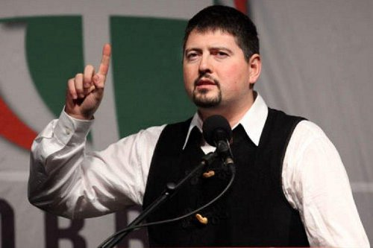

For Csanád Szegedi, it was “the most traumatic and probably the worst day of my life.”
The guest speaker at Aish Hatorah South Africa’s gala dinner held in Johannesburg last week, Szegedi related how, as a 20-year-old university student in 2003, he had co-founded the far-right, anti-Semitic Jobbik Party; created concomitantly was a paramilitary organization, Hungarian Guards, which struck terror into the hearts of minorities, making him the embodiment of Hungarian Jewry’s worst fears.
By 2012 Jobbik had grown to be the second largest political party in Hungary. It was at this time that a political rival claimed to have documentary proof that Szegedi was in fact Jewish.
“To clarify the rumour, I sat down with my maternal grandmother to ascertain whether this was true,” he recalled through his colleague and translator Jonathan Megyeri. “My grandmother, who had survived Auschwitz and had a number tattooed on her arm, admitted she was once Jewish, but she had closed that chapter after the Shoah and was not Jewish anymore.
“She said my maternal grandfather was also Jewish and had worked in a forced labour camp during World War 11.”
There was no escaping the shocking truth: Csanád Szegedi was a Jew.
His inner turmoil was compounded by the fact that his appearance did not gel with his internalized image of Jews. “I cannot be Jewish,” he thought to himself. “I don’t have a big enough nose, a hunchback and two bags of money under my arms!”
Szegedi, who had never encountered a Jewish individual, decided he had to meet a “real Jew”, specifically from the religious community. “But I did not have many rabbi friends,” he notes in something of an understatement.
So he googled “Budapest rabbi” and found one who worked in outreach. At first the rabbi thought he was joking. “He suspected it was candid camera,” Szegedi remembers.
“He gave me an appointment and I went to see him. I thought he was going to throw me out. Much worse – he told me I should sit down and learn!”
With his wife, Szegedi was invited to synagogue where “I held the book upside down.” The enmity and hatred he encountered there was so great that the rabbi had to call a meeting, where Szegedi faced some aggressive questioning from the community.
“Despite all this, I thought I have no other way to choose but to walk the Jewish way.” He has since become kosher and Sabbath observant.
During his interrogation by the community, an old man had asked him “very softly” when he was going to be circumcised, something he refers to as “not my favourite part of Judaism.” A year later, after the procedure “which I never thought I’d undergo,” Szegedi received his first “aliyah” on Yom Kippur.
“It was the first time I had the opportunity to be called by my Jewish name,” he relates. “The old man came up to me and said: ‘I pardon you now.’”
In the light of these developments, have his mother and grandmother embraced their Judaism? “I have had long conversations with both,” he says, “and I must admit that neither was particularly happy with the outcome of events.
“My grandmother worked so hard for the past 50 years to try to assimilate and it seems she failed in the end. My mother is simply afraid of embracing her Jewish roots.”
While his grandmother passed away a year ago, Szegedi’s mother, who had no knowledge of Judaism, has accompanied him to synagogue on a few occasions and he has taken her on a visit to Israel.

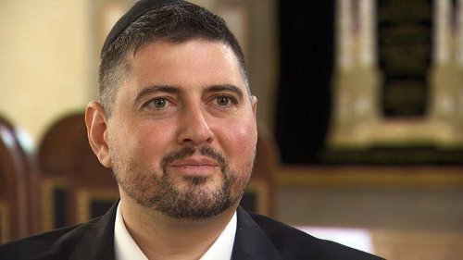

The 33-year-old now says he is “not too proud” of the fact that he was second in command of the proto-Fascist party and for three-and-a-half years has been “extremely busy” attempting to atone for his past.
Amidst much emotional upheaval, the main issue engaging his mind was how to make up for “all the bad deeds” in his previous life. The Av Beth Din in Budapest suggested he go around to schools, college campuses and universities explaining the dangers of anti-Semitism, as well as address Jewish communities, all of which he has been doing for the past 18 months.
But has he done anything to eradicate anti-Semitism amongst the people he used to lead? The question is whether it is worthwhile to engage in conversation with someone who is anti-Semitic, especially where political interests are concerned, he retorts, seemingly sidestepping the issue.
Since Jobbik is the most popular party for those under 30, there is “something wrong with the education system if all the youngsters could be attracted to this type of nonsense.”
He is, however, not shirking his personal responsibility. “I am far from being satisfied that my lecturing does the job,” he concedes. “I try to do everything I can through my story to get my ideals out in public.”
To this end, Szegedi is writing a book and a documentary film is in the pipeline. “My story will get to more people and I could have more influence than I have,” he says.
While he has endured threats from his former party, these are “mainly over. I received many e-mails. Some people in the party are very aggressive, but this never led to any real danger.”
“What makes someone anti-Semitic?” he ponders, voicing the eternal question. “I had never met a Jewish person in my life.”
Indeed, how then did he pick up on these ideas? Szegedi attributes this to having grown up amongst young people who were “very nationalistic.” In addition, “anti-Semitic literature became available in the 1990s and I did a lot of reading,” he says, fingering the explosion of the Internet. “You must be careful what young people access,” he warns.
“Anti-Semitism cannot be rational – it stems from frustration and depression. I did not meet the kind of monsters portrayed in anti-Semitic circles,” he says of his integration into the Budapest Jewish community.
“The only thing to do to fight anti-Semitism is to do more to be Jewish, be proud and definitely do not hide it,” he concludes.
While Szegedi’s wife is not Jewish “yet,” she has embraced his change in direction, describing it as a “new path we can only walk together.” Previously, she had been neutral to “a little bit positive” towards Jews, he explains.
“I firmly believe you cannot run a Jewish home without the support of the woman,” he states. “While I had my doubts along the way, she was always supportive and pushed me in the right direction.
“She put magnets on the fridge with the different blessings for food. She’s the one that dresses my kids up for Shabbos,” he says, referring to their two sons aged four and seven years. “We started this path together and I thank her very much.”
As for coping with the Hebrew prayers, Szegedi says although the language is logical, it is “not easy for the European mind. I could probably count on the fingers of one hand, the number of times my rabbi was happy with me!”
Sharing the “main message” of his life, Szegedi states: “Some of you may not consider yourselves observant, but I doubt that any of you went further away from G-d than I did.
“G-d has proven to me that He is not particularly looking for vengeance, but He’s also very (quick) to pardon.”
As to his three core reasons it is worthwhile being Jewish, he says: “You are Jewish anyway, so you might as well enjoy it! From a spiritual point of view, we belong to a nation that G-d watches over personally.
“Most importantly, we’re part of a family that, thanks to organizations like Aish HaTorah, welcomes back every lost member. Thank you, my South African family, for welcoming me.”

Reprinted from last week’s email of Aish.com

The Kopishnitzer Rebbe and Two Jews Smoking on Shabbos

Rabbi Zelig Pliskin explains (Love Your Neighbor, p. 279) that the goal of giving rebuke to someone is to correct the wrongdoer. In every situation we must weigh that particular case and use the best possible way to accomplish this. The most important rule is to administer the rebuke with love and as painlessly as possible, and when the receiver sees that he is sincerely loved, he will readily accept it.
This can be beautifully illustrated with a story about the Kopishnitzer Rebbe, Rav Avraham Yehoshua Heschel, when the Rebbe lived on Henry Street on the lower East Side of Manhattan.
One Shabbos, the Rebbe noticed two non-religious Jews standing out on the street, each smoking a cigarette. The Rebbe’s Ahavas Yisroel, his love for his fellow Jew, was legendary and he could not pass by them without sharing his concern.
He began to speak to them in a soft and gentle tone. “Good Shabbos, Yidden (Jews)”, and respectfully, they replied, “Good Shabbos, Rebbe.”
The Rebbe gently said, “May I ask you a question?” and they said, “Of course.” The Rav said to them, “Shabbos is such a holy day, and you are such fine Jews. Why are you smoking on this holy day?”
One of the men answered, “Rebbe, do you know what they say in America? Mind your own business!”
The Rebbe was unfazed and asked them another question. He said, this street that we are standing on is very busy and has many cars going back and forth. If someone would Chas V’Shalom (Heaven Forbid) be hit by a car and would be lying there bleeding heavily, would you also say, “Mind your own business?”
The man said, “Of course not, Rebbe! If someone is lying there bleeding to death, of course we would help him!”
The Rebbe continued, “Well, it is the same situation here. I see two fine Jews standing on the street with their souls bleeding to death. How can you tell me to mind my own business? Can you blame me for wanting to help them?”
The message resounded within them and the two men immediately threw the cigarettes away and promised to never smoke on Shabbos again!

Reprinted from the Parshas Lech Lecha 5776 email of Torah U’Tefilah: A Collection of Inspiring Insights Compliled by Rabbi Yehuda Winzelberg.

It Once Happened

A Young Child’s Prank

When the Rebbe Shmuel of Lubavitch was a young child he was unusually serious, but often a bit mischievous.
One day, when he was just six or seven years old and searching for a quiet place to sit and learn Torah, he decided to try the women's section of the Shul. But suddenly the silence was broken by sound of the side door opening followed by the sobs of a woman. He silently walked to the front of the balcony and peeked down to the main floor. There he saw a woman standing before the Holy Ark, weeping uncontrollably.
"G-d, please help me!" she moaned. "I'm alone! I've tried to work; I've tried everything. But the house is bare and my children are starving! My husband is dead, all I have is You. Please answer my prayers, G-d!"
Little Shmuel felt he had to do something. She was disturbing his learning and besides, he couldn't stand to see suffering. He ducked down behind the low wall and said in the lowest voice he could conjure. "Lady! Lady! Do not worry!" The high ceiling of the empty Shul created a sort of heavenly echo that made it seem as though his voice was coming from everywhere.
The woman fell to her knees, looked up at the ceiling, raised her hands towards heaven and sighed "Oh! Oh! Thank you, L-rd!" When he saw it was working he continued, "Do not cry! You will have money. I am giving you the power to heal! When someone is sick, just take a glass of water, make a blessing on it, drink a bit, pour a bit for the sick person, and then bless them. People will pay you much money and you will never be needy again!"
Then the boy paused dramatically for a moment and said, "But remember! Never tell anyone how you got this power." "Oh, I won't. I promise!" She innocently replied. "Thank you, L-rd. Thank you! I won't tell a soul. Oh, this is wonderful!"
The next morning she got to work spreading the word that she could heal, and that very day someone brought their sick father to be cured. She felt a bit strange but she did as the voice had told her the day before and amazingly, it worked. The man actually felt better!
The news spread like a forest fire and in no time people were lined up at her door. She transformed from a pauper to a fairly wealthy woman in just a few weeks. The years passed. About 25 years later the child, Shmuel, became the Rebbe "Maharash" of Chabad, renowned throughout Russia for his genius and his holiness. Thousands flocked to his center in Lubavitch to obtain his blessings and his advice.
Then, one cold winter he became dangerously ill. He had developed a boil that had become seriously infected and his health deteriorated rapidly. The Rebbe had a high fever and it appeared there was no alternative but to operate. Then someone suggested that maybe, as a last resort, they should try Bubba (Grandma) Sarah. It seems there was this old Jewish lady in Vitebsk that had some charm for healing people and because there was no other choice she was brought, trembling with awe at the thought that she was actually in the same room with the holy Lubavitcher Rebbe, to heal him.
The Rebbe was lying on his back, his head propped up by a large pillow breathing with great difficulty and in obvious pain. But before she could even begin he asked, "First you must tell me what the source of your power to heal is."
"Oh, Rebbe!" moaned the old woman. "Please don't ask me to do that. I promised that I wouldn't tell. Please Rebbe!" But the Rebbe insisted. "I promise that nothing will happen to you or your remedy." After all, G-d also tells me things that are secret, so He won't mind if I know your secret too. In any case, I cannot take your treatment until you tell me."
How could she deny the holy Rebbe? She told him the entire story of how 25 years ago a heavenly voice spoke to her in the shul. Suddenly the Rebbe realized that it was he himself that had given her the blessing and he began to laugh. It was painful because of the boil, but the more he thought about it the harder he laughed, he simply couldn't stop himself.
His family, hearing the noise from where they were in the next room, thought the Rebbe was having some sort of attack and rushed into the room after sending for the doctor. The doctor arrived just in time to see that the Rebbe's exuberant laughter had split the boil open and now all that remained was to clean the wound. In just days the Rebbe was back on his feet, a completely healthy man!

Reprinted from the Parshas Bereishis 5776 edition of “L’Chaim Weekly,” a publication of the Lubavitch Youth Organization in Brooklyn, NY.
Story #935

The Modern Slaughterer
With an Ancient Knife
From the desk of Yerachmiel Tilles
editor@ascentofsafed.com

After the passing of the major chasidic rebbe, R. Uri of Strelisk, known as "the Seraph" ["the fiery angel"), the leadership of his followers passed to his primary disciple, Rabbi Yehuda Zvi-Hirsch of Strettin. However, not all the chasidim accepted his leadership whole-heartedly; some were still hesitant whether he was truly worthy to take the place of his predecessor.
On one of the new rebbe's journeys together with a group of the chasidim, he directed them to proceed into the city of Pesht (today part of the Hungarian capital of Budapest). As they wheeled along the main street, they passed a butcher shop. The Rebbe told the driver to stop in front of it. Above the entrance hung a prominent sign: "Here one may buy kosher meat of the highest standard."
The Rebbe stared intently in the wide front window. Suspended there from a hook in the ceiling was a large piece of meat for sale that appeared fresh, juicy and tender.
The Rebbe turned to two of the chasidim and asked them to go find out what was the name of the shochet (kosher slaughterer) and where he lived. He added softly that today perhaps they will eat of this meat.
The chasidim were not clear from his tone if he was asking or telling them. Their faces stretched in puzzlement upon hearing the out-of-character request of the tzadik. Well known was his dedication to personal spiritual advancement, and thus aversion to fancy foods and other worldly pleasures. Yet here he was seemingly intending to feast upon would probably be a delicious-looking piece of meat.
The pair assigned to the task were quick to clarify the identity of the shochet and his address. The Rebbe promptly announced that they would all go there together.
They found the house and knocked on the door. The shochet's wife opened and welcomed them with a happy smile. Her appearance was of a fully modest Jewish woman, while her face radiated kindness. One of the chasidim who had tracked down the address asked where her husband was and she answered that he was expected home soon.
When the Rebbe then asked if there was a possibility that he and a few of his chassidim could sleep in their house that night, she quickly invited them to do so. "If so," said the Rebbe, "we all need to eat supper first. Can you provide us a meal with meat?"
"Of course," she responded. "With pleasure." And she began setting the table.
The chasidim stared in amazement. Why was the Rebbe requesting to eat specifically meat? And in a house that he knew nothing about and from a slaughterer he was not acquainted with. It was beyond belief. Still, not one of them could gather up the nerve to ask their leader about his highly irregular request.
Not so long after, the door opened and in walked the shochet. Immediately the perplexity of the chasidim accelerated. His thick overcoat, large fur hat and heavy boots were in the style of the Polish nobility. The garments under his coat were tailored to the current modern fashion, a manner completely unacceptable in G-d-fearing Jewish communities then, especially for a shochet. How could it be that the Rebbe would eat in the house of such a person, and trust his slaughtering and his kashrut observance? It was inconceivable.
The rebbe and the shochet greeted each other pleasantly. Before sitting down for the meal, the Rebbe, who had worked in his younger years as a shochet, asked politely to examine thpe knife [i.e. the sharpness of its blade and its smoothness --yt] that was used to slaughter the meat which was being served.
To everyone's wide-eyed astonishment, the shochet refused to comply, even though this was a traditional and acceptable request for a very religious guest or customer to make. His expression turned severely serious as he said, "Please excuse me, your honor. I will not be at all offended if you or your students refuse to eat from our meat. But under no circumstances can I show you my knife!"
The chasidim were aghast at the refusal to honor their rebbe's reasonable request. The tzadik, however, was not fazed. He requested of the shochet that the two of them step into a separate room. Once they were in privacy, he revealed his identity fully as Rabbi Yehuda Zvi-Hirsch, head of the rabbinical court of Strettin, and declared that with the supreme authority of the Torah he decrees upon the shochet to present to him his slaughtering knife.
The shochet turned pale, realizing that according to Jewish law he no longer had a choice. He quietly fetched the knife and put it in the Rebbe's palm, handle first. The Rebbe held it by the handle and examined its blade. He was deeply impressed; the edge of the blade was extremely sharp and completely smooth.
Then he noticed there were letters carved into the handle. He looked closer and was astonished to see the following extraordinary inscription:
"This is the knife of Avraham our forefather, peace unto him, that we eat in his merit [the meat slaughtered with it]."
It took Rabbi Yehuda-Zvi a few moments to calm his emotions and regain his equilibrium. After another gaze at the inscription, he walked slowly out of the room. His host followed solemnly behind. The Rebbe sat down at the table and with a broad smile told his chasidim they could join him to eat, including the meat. They greatly appreciated the meal, while their host, the shochet, relieved that the Rebbe had not mentioned the inscription, took particular pleasure from the Torah thoughts that the Rebbe shared.
Actually, not all of the chasidim ate from the meat. The faith and trust of a few of them in the new rebbe was not so complete as to alleviate their concerns about the kosherness of the food and their suspicions of the shochet. Each one surreptitiously pushed the meat on his plate onto the handkerchief he had placed on his lap, in order to throw it away outside after the meal at a quiet moment.
The next morning the group rose early, and after prayers and a small breakfast they departed. Only when they reached a good distance from the city did the Rebbe tell them about the startling inscription on the knife. The chasidim all cried out in shock, some with joy that they had merited to eat from meat that had been slaughtered with the knife of Avraham Avinu (our father Abraham), the minority from sharp disappointment that they hadn't believed in the Rebbe enough to rely on his invitation.
Those latter chasidim decided they would immediately return to Pesht and again request hospitality in the home of the shochet. Then they too would be able to eat of the meat slaughtered by his unique, holy knife.
When they arrived in Pesht, they set out in the direction of the slaughterer's house. But they weren't able to locate it. After fruitlessly wandering up and down the street and a few other adjoining ones, they started asking local people for help. But each one that spoke to said he was not acquainted with such a shochet, and insisted that there had never been such a butcher store in the city.
Realization dawned on them. The shochet must be one of the 36 hidden tzadikim, in whose merit the world continues to exist. That he had accepted them into his home and interacted with them could only be in honor of their rebbe, R. Yehuda Zvi, the tzadik of Strettin. If only their faith had been greater, they too would have had the privilege of eating from the knife of our patriarch Avraham.
Source: Translated by Yerachmiel Tilles from the Israeli Hebrew weekly, Sichat HaShavua (#1397), with a few additions from other written sources.
Editor's note: Strettin at the time of the story was in Galicia, a part of the Austrian empire. Today it is in western Ukraine (look in middle of map).
Biographical note: Rabbi Yehuda Zvi-Hirsch Brandwein of Strettin [of blessed memory: 5540 - 11 Iyar 5604 (1780 - April 1844 C.E.)] was the leading disciple of Rabbi Uri of Strelisk, whom he succeeded in 1826, and whom he resembled in his ecstatic mode of prayer. He was highly praised by many of the tzadikim of his generation. His teachings may be found in Degel Machaneh Yehuda. He was succeeded by his son Rabbi Avraham Brandwein of Strettin.
Connection: [Midrash on] weekly reading 1) Gen. 18:7 with Rashi--The patriarch Avraham slaughtered three calves, one for each of his three guests. 2) Gen. 22:6,10-the knife of Avraham Avi

Reprinted from last week’s email of KabbalOnline.org, a project of Ascent of Safed, www.ascentofsafed.com ascent@ascentofsafed.com

Har Nof Rabbi
Dies of Wounds
By Yaakov Kristal

Remembering Rabbi Chaim (Howie) Yechiel Rothman who succumbed to the wounds he sustained during the Har Nof Massacre.

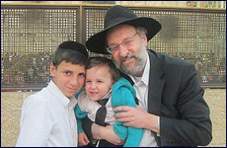

This week, on Cheshvan 25, 5776, it will be a year since the Har Nof Massacre took place. The memories of those righteous men who were brutally murdered are still fresh on our minds; we still ache from the pain.
Hearing the repeated recitation of kaddish from the orphans was a constant reminder about the massacre. Just two weeks ago they finished saying kaddish for their parents who died on Kiddush Hashem. This was a partial comfort for us.
But tonight, on the 12th of Cheshvan, almost a year later, a new cycle of kaddish will begin. Our wounds have been ripped open by the death of my beloved neighbor and dear friend, Rabbi Chaim Yechiel Rothman Hy’d.
Rabbi Chaim Yechiel Rothman sustained blows to the head with an axe during the massacre. Since then he had been in a coma-like state. Every day we pleaded to the Almighty to bring him back to us. On Friday night at dusk, just as Shabbos was entering, Chaim’s soul left this world and returned back to the Almighty.

A Kind Soul
Chaim’s mother, Mollie, shared with us that when he was six years old he was driving with his parents in a car and out of the window he noticed a young girl, about five years old, crying next to an overturned doll carriage. He asked his parents to stop the car. He got out and turned over the doll carriage to comfort this little girl.
Chaim grew up with two brothers and two sisters in Toronto, Canada. During his teenage years once a week he would visit a Jewish nursing home. Chaim would dance with the patients while they were in a wheelchair, and he succeeded to lift up the spirits of everyone he came in contact with.
Ten years ago Chaim’s son was tragically killed at the age of 17 after falling off a cliff while riding his bicycle through the Jerusalem Forest. Yet this great loss did not change the way he dealt with others. He maintained his cheerful countenance even in the midst of such a tragedy.
Chaim spoke to others in the happiest and gentlest tones. His voice emulated peace and loving kindness. Just being around him made one happy and feel love for other Jews.
Chaim’s funeral was on a Motzei Shabbos, Saturday night, a time which does not generally clash with people’s schedules. Furthermore, it was on the same night that we turned the clocks back, giving people an extra hour of sleep to make up for the late ending of the funeral. I could not help but think that even in his death Chaim was try to do everything he could to cause as little disturbance as possible to others.

Lover of Torah
It is not difficult to do big acts which put one in the limelight of the public spectrum. The true sign of a great person is how he performs small acts. I have been privileged to be Chaim’s close friend and neighbor for the past ten years and have personally witnessed many small acts of greatness.
Chaim loved and cherished Torah. Whenever we would meet he would ask me to tell him novel Torah teachings. He would listen with full intention, as if he was hearing the greatest insights.
For the past 23 years Chaim has been studying with a prominent Rosh Kollel in Jerusalem, Rabbi Baruch Tanzer who said that he never had a chevrusah, study partner like Chaim Rothman. Rav Tanzer continued to travel from Har Nof to Ranana to study with him, even after the massacre took place.
Our Sages teach that we should run to do mitzvot, “as if we are being pursued by a lion” (Berachot 6b). I do not believe that I have ever seen anyone fulfill this law with the exception of one person; Chaim Rothman who I have personally witnessed running to shul early with his tallis and tefillin.
His wife, Risa, has gone through unbelievable challenges during this past year not knowing if her husband was dead or alive. She has the support of the other four widows, her family and the entire community who stood and will continue to stand by her side.
Rabbi Yitzchak Mordechai Hakohen Rubin, the Rabbi of Kehilas Bnei Torah where the massacre took place, said, “If we had a thought that we would forget about our holy victims after 12 months, death once again peeks through the window. We cannot possibly forget what happened. The number of widows has gone up to five and the number of orphans is now 35."
Let us hope that mashiach will be here soon and bring a fulfillment to the promise, “Death will be destroyed forever, and tears will be wiped off of the faces of all.”

DONATIONS TO HAR NOF FAMILIES
ISRAEL www.kupat.org Israel: 1-800-39-47-47 Kupat Ha'Ir – Pob 49 – Bnei Brak Fund #2159
USA: American Friends Of Kupat Hair, 4415 14th Avenue Brooklyn NY 11219(888)-587-2842 online: www.kupat.org/how-to-contribute/ NOTE: Har Nof Families – General Fund #2159

Reprinted from last week’s email of Aish.com

